### A REPORT ON

Personalized Diet Planning System

SUBMITTED TO THE SAVITRIBAI PHULE PUNE UNIVERSITY, PUNE IN THE PARTIAL FULFILLMENT OF THE REQUIREMENT OF

**PROJECT BASED LEARNING (SECOND YEAR ENGINEERING)**

### SUBMITTED BY

|  |  |
| --- | --- |
| STUDENT NAME: | Exam No: |
| PANKAJ KUMAR | S1902204283 |



**DEPARTMENT OF COMPUTER ENGINEERING**

### ARMY INSTITUTE OF TECHNOLOGY

DIGHI HILLS, ALANDI ROAD, PUNE 411015

### SAVITRIBAI PHULE PUNE UNIVERSITY 2024 – 2025



## CERTIFICATE

This is to certify that the project report entitled

“Personalized Diet Planning System”

|  |  |
| --- | --- |
| PANKAJ KUMAR | S1902204283 |

Submitted by

is a bona fide student at this institute and the work has been carried out by them under the supervision of Mrs. **Pradnya Tapkir** and it is approved for the partial fulfillment of the requirement of Second-year course on Project Based learning of Savitribai Phule Pune University.

|  |  |
| --- | --- |
| (Mrs. **Pradnya Tapkir**) | **( Dr. Sunil Dhore )** |
| Guide | Head |
| Department of Computer Engineering | Department of computer  Engineering |

(Dr. B. P. Patil) Principal

Army Institute of Technology, Dighi Hills, Pune – 411015 Place:

Pune Date:

## ACKNOWLEDGEMENT

I would like to use this opportunity to thank my team members, without whom this project would not have been possible. Their support and co-operation played a pivotal role in the success of this project.

I would like to express my special thanks to our guide and supervisor Ms. Pradnya Tapkir, as well as our principal Dr. B. P. Patil who gave me the excellent opportunity to do this wonderful project on the topic “e-vote system Website”, which also helped me in doing a lot of Research in website development and I came to know about so many new things in web development… I am really thankful to them…

I would also like to thank my college and university for providing such a nice platform to learn, understand and implement our ideas.

## NAME OF THE STUDENT - PANKAJ KUMAR (3232)

## ABSTRACT

A diet planning system is a digital platform that facilitates the process of creating, tracking, and managing personalized nutrition plans. Designed to enhance health awareness, consistency, and dietary decision-making, NutriPlan allows users to build custom meal plans, monitor nutrient intake, and align their eating habits with personal health goals using devices such as computers, tablets, or smartphones.

These systems typically require users to input preferences, dietary restrictions, and goals before accessing a tailored nutrition interface. Once set up, users can view meal suggestions, receive reminders, and log food intake securely. The system then analyzes and stores this data, ensuring personalized recommendations and actionable feedback throughout the health journey.

Many diet planning platforms also include real-time analytics features, such as nutrient summaries or progress charts, allowing users to evaluate their adherence and modify their plans accordingly. Additionally, advanced systems may integrate with fitness wearables or biometric tools to enhance personalization, encourage consistency, and deliver measurable results.

These systems often offer user-friendly tools for meal scheduling, grocery planning, and recipe exploration, simplifying the process of adopting and sustaining a healthy lifestyle. Visual guides, reminders, and accessibility features improve engagement, while secure data handling protects user privacy.

Overall, diet planning systems offer a practical, scalable, and personalized alternative to traditional nutrition tracking methods. By leveraging technology, these platforms aim to improve dietary behavior, support long-term health goals, and empower users to take charge of their wellness in today’s digital world.

## TABLE OF CONTENTS

LIST OF ABBREVIATIONS vi

LIST OF FIGURES vii

LIST OF TABLES viii

### CHAPTER TITLE PAGE NO.

|  |  |  |  |  |
| --- | --- | --- | --- | --- |
| **Sr. No.** | | | **Title of Chapter** | **Page. No.** |
| **1** | | | **Introduction** | **1** |
|  | 1.1 | | Overview | 1 |
|  | 1.2 | | Motivation | 1 |
|  | 1.3 | | Problem Definition & Objectives | 2 |
|  | 1.4 | | Project Scopes & Limitations | 3 |
|  | 1.5 | | Methodologies of Problem Solving | 6 |
| **2** | | | **Literary Survey** | **7** |
| **3** | | | **Design** | **8** |
|  | 3.1 | | Systems Design | 8 |
|  |  | 3.1.1 | Article/Tutorial Section | 8 |
|  |  | 3.1.2 | Statistics Section | 9 |
|  | 3.3 | | Technology Stack | 11 |
| **4** | | | **Project Plan** | **12** |
|  | 4.1 | | Project Resources | 12 |
|  | 4.2 | | Team Organization | 13 |
|  |  | 4.2.1 | Task Network | 13 |
|  |  | 4.2.2 | Project Schedule | 13 |
| **5** | | | **Results** | **14** |

Army Institute of Technology, Department of computer engineering 2024-25

|  |  |  |  |
| --- | --- | --- | --- |
|  | 5.1 | Outcomes | 14 |
|  | 5.2 | Screenshots | 14 |
| **6** | | **Conclusions** | **15** |
|  | 6.1 | Conclusions | 15 |
|  | 6.2 | Future Work | 16 |
|  | 6.3 | Applications | 17 |
|  | 7 | **Reference** | 18 |
|  | | | |

LIST OF TABLES

### TABLE ILLUSTRATION PAGE NO.

* + 1. Task Network 13
    2. Project Schedule 13

## INTRODUCTION

### OVERVIEW

Introducing NutriPlan, the ultimate diet planning platform. Create personalized meal plans, track nutritional intake, and access dietary information for informed health decisions. Never miss your nutrition goals with our user-friendly interface and timely reminders. NutriPlan ensures your health journey is supported, making nutritional management easy, effective, and accessible to all.

### MOTIVATION

At NutriPlan, we understand the challenges of maintaining a balanced diet in today’s fast-paced world.

Our system empowers you to plan and track your nutritional intake conveniently and securely from anywhere.

With timely reminders, step-by-step guidance, and robust nutritional analysis, we’re here to make your health journey smooth, effective, and impactful.

**PERSONAL MOTIVATION**

We were motivated to develop a diet planning system because we believe everyone should have equal access to nutritional education and tools. This system helps people manage their diet conveniently and effectively, encouraging consistent healthy eating habits and contributing to a more health-conscious, informed, and empowered society.

* + - * 1. **PROBLEM DEFINITION & OBJECTIVES**

Problem definition:

Millions of people around the world face challenges in maintaining a healthy diet and nutrition plan. Many struggle with consistent meal planning due to busy schedules, lack of nutritional knowledge, or ineffective tracking methods, which can weaken overall health outcomes.

This is especially true for those with specific dietary requirements, health conditions, or weight management goals.

Failing to maintain proper nutrition can result in:

* Poor health outcomes, which impacts quality of life and healthcare costs
* Nutritional disengagement, particularly among younger and busier populations
* Declining trust in dietetic advice, and reduced adherence to dietary recommendations

The issue of inconsistent dietary habits is a major concern globally. In many nations, it's estimated that up to 50% of adults don't maintain a balanced diet that meets their nutritional requirements.

# Objectives:

The objectives of this project are to:

Enhance Nutritional Awareness – The diet planner aims to boost nutritional literacy by offering personalized, convenient, and accessible meal planning, reducing poor dietary choices, and strengthening healthy eating habits.

Provide User-Friendly Interface – The system is designed to be easy to use, with a clear and intuitive layout, catering to users with varying levels of nutritional literacy and digital expertisOffer Customization and Personalization – Users can tailor their experience with meal reminders, preferred dietary restrictions, and secure access, making the nutrition planning process more comfortable and user-focused.

The project is expected to simplify diet planning for individuals. It will also assist them in remembering nutritional goals, contributing to stronger health management.

### PROJECT SCOPE & LIMITATIONS

Project Scope:

Nutritional Engagement:

A diet planning system primarily tackles the issue of poor nutritional habits. It enables users to plan meals conveniently from their own devices, reducing knowledge barriers and increasing engagement. The system functions as a powerful tool to promote consistent adherence to healthy eating habits.

**Personalized Nutrition**

**Features:** A major advantage of a diet planning system is its ability to provide personalized features. Users can schedule meal reminders, choose preferred dietary restrictions, and set up notification methods like email or SMS, all tailored to enhance individual nutritional engagement and convenience.

Progress Tracking**:**

Besides meal planning, the system allows users to track nutritional intake and progress toward goals. This feature promotes accountability and can help users identify patterns, measure dietary activity, and improve future health planning.

Informational Tools:

Diet planning platforms include educational resources such as nutritional facts, meal preparation instructions, and recipe calendars. These tools aim to inform users and support thoughtful decision-making, ensuring users have access to reliable and unbiased nutritional information.

Accessibility and Device Compatibility:

Diet planning systems are developed to work on various digital platforms such as smartphones, tablets, and computers. This ensures ease of access, allowing users to engage with the system wherever they are, at their own convenience. The interface is typically user-friendly, enabling efficient navigation and setup.

Project Limitations:

User Commitment:

Although the system provides all necessary tools, the responsibility to follow nutritional plans still lies with the user. It cannot force adherence or ensure users take action—it simply makes the process easier.

Technology Requirements:

The platform depends heavily on digital infrastructure. Users without internet access or compatible devices may face challenges using the system, limiting its effectiveness in underserved areas.

Potential System Errors:

Despite best efforts, technical glitches, delays, or software failures may occur. These issues could disrupt the planning process and must be managed with backups and real- time support.

Nutritional Complexity:

Diet planning must account for diverse nutritional needs and restrictions. The system may encounter limitations depending on specialized dietary requirements, especially concerning medical conditions, allergies, and cultural preferences.

Data Protection and Security:

Handling sensitive data such as health information and personal preferences requires strict encryption and privacy protocols. Developers must ensure systems are compliant with health regulations and are resilient to breaches.

Limited Professional Oversight:

Online platforms lack the physical oversight of nutritional professionals. Users must rely on digital algorithms and automated systems, which may not address all individual health concerns or provide real-time professional assistance. Therefore, it should complement— not replace—professional dietetic consultation entirely.

### METHODOLOGIES OF PROBLEM SOLVING

User Research:

User research is conducted to understand the expectations, concerns, and preferences of the people who will use the diet planning system. This includes gathering feedback from individuals, nutritionists, and health experts through surveys, interviews, or usability studies. The research helps identify challenges such as dietary restrictions, nutritional confusion, or difficulties with meal planning, guiding the overall system design and development.

Requirement Analysis:

This step involves determining the essential features and goals of the diet planning system. It includes outlining the core functionalities such as nutritional calculation, meal suggestion, dietary restriction management, and progress tracking. This analysis ensures that the system aligns with health standards, ethical considerations, and

technical requirements, while addressing potential nutritional misunderstandings and building trust among users.

User Experience (UX) Design:

UX design is crucial to ensure that the diet planning process is intuitive, informative, and accessible to all users. Wireframes and prototypes are created to map out the interface, and iterative feedback is used to improve the design. Clear navigation, responsive layouts, and simplified instructions help users plan meals confidently and avoid nutritional errors during the process.

Development and Testing:

Once the design is finalized, the development process begins, where the diet planning system is coded and its features are implemented. This includes nutritional database integration, personalized meal planning algorithms, and progress visualization tools. Thorough testing is conducted, including nutritional accuracy verification and compatibility checks across various devices and browsers, to guarantee a reliable, seamless, and trustworthy diet planning experience.

## LITERARY SURVEY

Several studies have explored the design, implementation, and impact of digital diet planning and nutrition management systems on user health outcomes, behavior change, and engagement. Below is a selection of the most relevant and insightful studies that inform the development of NutriPlan:

1. Hutchesson et al. (2015) examined the effectiveness of mobile apps for dietary behavior change. Their findings indicated that personalized dietary feedback and user engagement features significantly improved adherence to recommended nutritional guidelines, suggesting that digital platforms can positively influence eating habits.
2. Chen et al. (2020) conducted a review of mobile health (mHealth) apps focused on diet and nutrition. They concluded that apps combining meal tracking with goal setting and educational content were more likely to result in sustained user interaction and health improvements, underscoring the value of integrated health management tools.
3. Lieffers and Hanning (2012) explored the usability of food journaling apps among young adults. Their study showed that simplicity, intuitive UI, and automated nutritional analysis were crucial to the consistent use of diet tracking applications, informing NutriPlan’s emphasis on a user-friendly interface.
4. Boushey et al. (2017) studied image-assisted dietary assessment tools. They demonstrated that visual features, such as photo-based meal logging and portion size estimation, helped users track food intake more accurately and reduced manual entry errors, inspiring NutriPlan’s potential use of image recognition for logging.

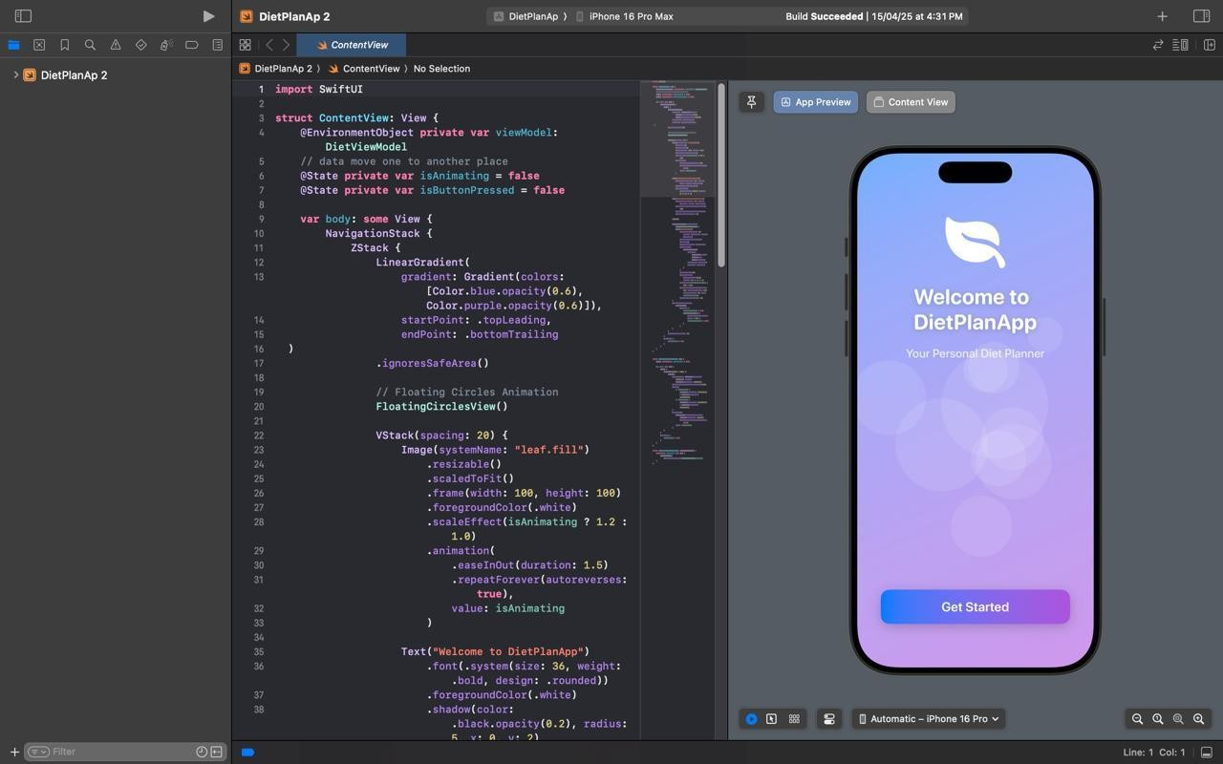

1. Schoeppe et al. (2016) analyzed engagement features in health- promoting apps and found that reminders, progress visualization, and customization options were key factors in encouraging ongoing app usage. This supports NutriPlan’s design philosophy of integrating smart notifications and personalized health tracking.

These studies provide critical insights into building effective and user- centered nutrition planning applications. They emphasize the importance of personalization, engagement, ease of use, and evidence- based content—core values reflected in the NutriPlan platform.

## DESIGN

### SYSTEMS DESIGN



**3.1.1. ARTICLE / TUTORIAL SECTION**

Article Section: Empowering Wellness through Smart Nutrition Planning

Introduction:

In today’s fast-paced world, maintaining a balanced diet can be a challenge. Nutritional planning is often overlooked due to time constraints, lack of knowledge, or difficulty in tracking meals. NutriPlan addresses these issues by offering a personalized, digital solution for meal planning and nutritional tracking. This article explores the significance of smart diet planning applications and the transformative impact they can have on public health.

1. **Importance of Nutritional Awareness:**

Good nutrition is a cornerstone of health and well-being. Poor dietary habits contribute to obesity, diabetes, heart disease, and other lifestyle-related illnesses. NutriPlan empowers users to make informed food choices, offering tailored meal suggestions that align with their health goals, dietary restrictions, and preferences.

1. **Introducing the NutriPlan App:**

NutriPlan is an intelligent diet planning application that helps users build personalized meal plans, track caloric and nutrient intake, and stay aligned with health goals. The system is accessible through smartphones and web browsers, offering a seamless cross-platform experience.

1. **Core Features and Functionalities:**

NutriPlan includes calorie calculators, macronutrient breakdowns, custom diet preferences (e.g., vegan, keto, diabetic-friendly), and integration with wearable fitness devices. Users can log their meals manually or via photo recognition, receive nutrition tips, and view daily and weekly summaries.

1. **Personalized Planning and Recommendations:**

The system leverages AI-based recommendation engines to tailor meal plans based on user inputs like age, weight, fitness goals, and food allergies. Adaptive learning continuously improves suggestions based on user feedback and progress.

1. **Eliminating Barriers to Healthy Eating:**

NutriPlan removes barriers such as diet complexity or lack of nutritional knowledge. By automating calculations and offering easy-to-follow plans, the app

helps users confidently navigate their health journeys without the need for expert intervention.

1. **User Engagement and Retention:**

Gamification elements, such as progress badges and wellness streaks, encourage consistency. Regular reminders and motivational tips are integrated to keep users on track with their goals.

1. **Data Privacy and Security:**

NutriPlan uses secure login protocols, encrypted databases, and anonymized health data storage to protect user privacy. GDPR compliance ensures users maintain control over their personal information.

Conclusion:

NutriPlan is a holistic health companion that makes diet management accessible and effective. By combining advanced technology with evidence-based practices, it empowers users to take control of their nutrition and improve their quality of life.

### 3.3 TECHNOLOGY STACK

The technology stack for NutriPlan is designed to ensure scalability, security, responsiveness, and ease of use across multiple platforms. It supports robust nutritional tracking, personalized meal planning, and seamless user engagement. Below is the core stack used in the development of the application: Programming Languages:

* Python (Flask / Django) for backend development, offering fast API creation and strong community support for health and AI applications.
* JavaScript with React Native for cross-platform mobile app development, allowing a consistent user experience on both Android and iOS.
* JavaScript (React.js) for a responsive and interactive web frontend. **Authentication and Security:**
* OAuth 2.0 for secure login through social media or email providers.
* JWT (JSON Web Tokens) for managing session tokens and secure user data exchange.
* Bcrypt.js for hashing passwords and securing sensitive user credentials. **AI & Recommendation Engine:**
* Scikit-learn and TensorFlow Lite for integrating machine learning algorithms used in meal recommendations and nutritional pattern analysis.
* Natural Language Processing (NLP) for interpreting food logs and dietary preferences.

User Interface (UI) and User Experience (UX):

* Figma or Adobe XD for designing high-fidelity prototypes and UI mockups.
* Tailwind CSS for building responsive, accessible, and modern interfaces quickly.

APIs and Integrations:

* USDA FoodData Central API or Nutritionix API for real-time food and nutritional data.
* Google Fit / Apple HealthKit for syncing physical activity and biometrics.
* Twilio / Firebase Cloud Messaging for sending personalized notifications and reminders.

Databases and Storage:

* PostgreSQL for structured data storage (user profiles, meal plans, logs).
* MongoDB for flexible storage of user-generated content and food logs.
* AWS S3 for storing user-uploaded images and files securely. **Analytics and Monitoring:**
* Google Analytics and Mixpanel for tracking user behavior and app engagement.
* Sentry and Firebase Crashlytics for real-time bug monitoring and issue resolution.
* ELK Stack (Elasticsearch, Logstash, Kibana) for advanced logging and dashboard visualizations.

This technology stack provides a strong foundation for building a secure, scalable, and engaging nutrition planning application. It is flexible enough to adapt to evolving user needs and integrate future advancements in AI and health tech.

* 1. **Project Resources**
     1. Development team (frontend and backend developers, UI/UX designers, security analysts)
     2. Project management tools (Jira, Trello)
     3. Design software (Figma, Adobe XD)
     4. Development environments (Visual Studio Code, IntelliJ IDEA)
     5. Cloud infrastructure (AWS, Microsoft Azure)
     6. APIs and libraries for encryption, authentication, and database management.
  2. **2.Project Schedule**

|  |  |
| --- | --- |
| **Week** | **Progress** |
|  |  |
| 1 | Discussions on what PBL is about and possible project topics. |
| 2 | Submission of ideas on two contemporary issues and our solution to them. |
| 3 | Finalized project idea to a online voting system |
| 4 | Start collecting data to eork on it… |
| 5 | Web programming is started… |
| 6 | Then after it styling and css part has done .. |
| 7 | After the functionalities it is read to deploy and function& project is finished… |
| 8 | Report writing… |

## RESULTS

### OUTCOMES

Website Is ready to use

### 1.2 SCREENSHOTS:

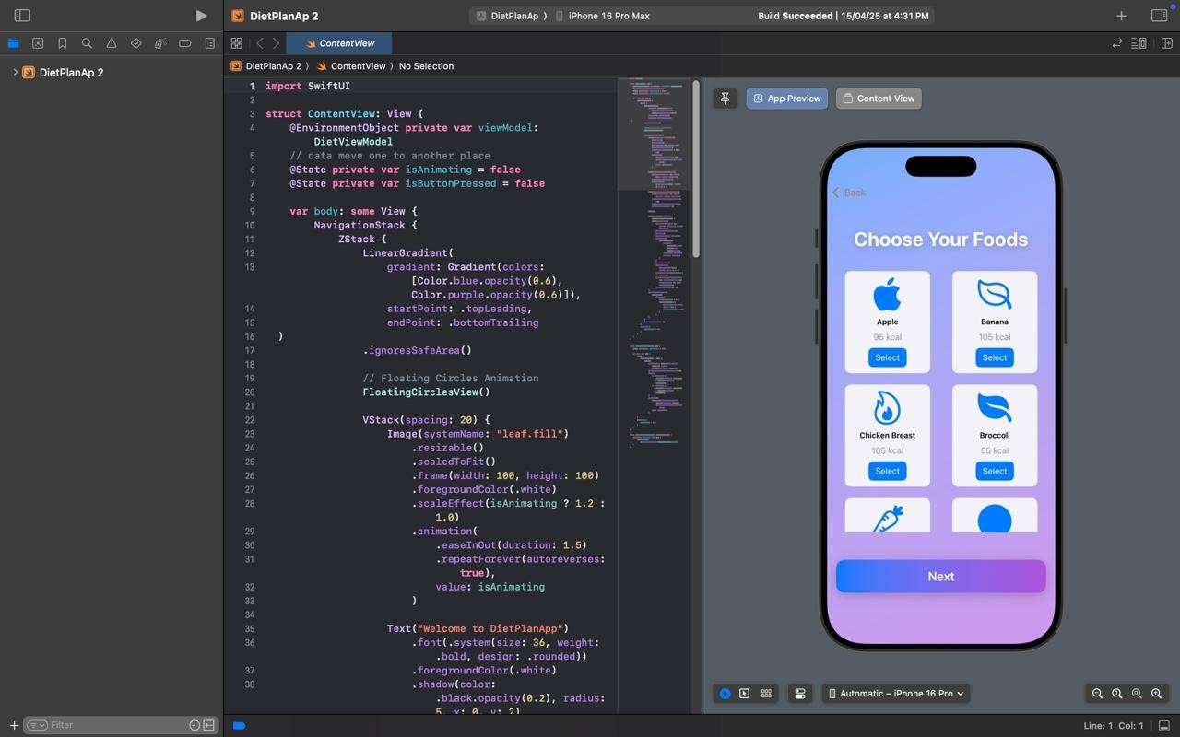

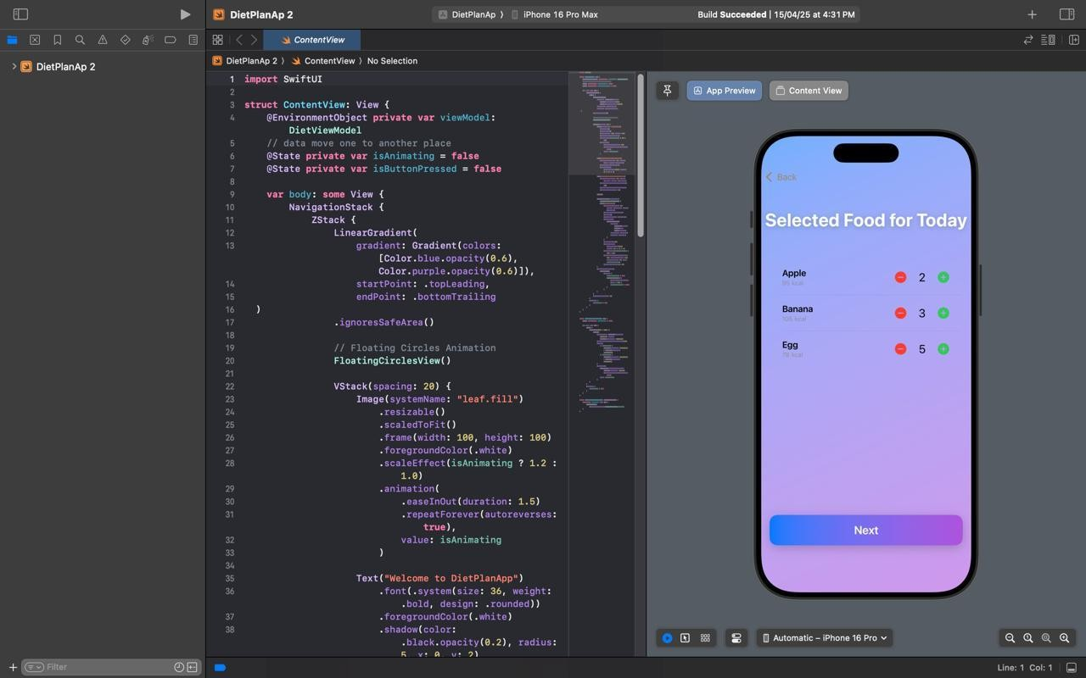

1. **CONCLUSIONS**

In conclusion, the development of *NutriPlan* represents a forward-thinking step in integrating technology with health and wellness. By combining personalized meal planning, intelligent tracking, and nutritional education, NutriPlan empowers individuals to take control of their dietary habits and achieve their health goals.

The application addresses key challenges faced by individuals trying to maintain a balanced diet—such as lack of nutritional awareness, difficulty in tracking intake, and inconsistent motivation. With features like AI-powered meal suggestions, real-time nutrient monitoring, and personalized reminders, NutriPlan simplifies complex dietary planning and promotes long-term healthy behavior.

NutriPlan contributes to digital health innovation by offering:

* Remote and Personalized Nutrition Management – Allowing users to access customized diet plans based on their preferences, medical needs, and fitness goals.
* Real-Time Health Monitoring – Enabling users to track daily caloric and macronutrient intake with ease, supported by analytics and progress feedback.
* Smart Reminders and Notifications – Keeping users engaged and consistent with their goals through motivational nudges and timely updates.
* Educational Insights – Providing access to verified nutritional information, recipe ideas, and health tips to support informed decisions.

This application not only enhances individual wellness but also has broader implications for public health, especially in preventing lifestyle diseases and improving dietary literacy. It can serve as a valuable companion in both personal and clinical nutrition management.

The success of NutriPlan depends on user engagement, accurate data analysis, and robust privacy measures. With thoughtful implementation, continuous updates, and user feedback, the platform can evolve into a comprehensive digital health solution, contributing meaningfully to better health outcomes across diverse populations.

Ultimately, NutriPlan seeks to make nutritional management more inclusive, proactive, and sustainable—fostering a healthier society through smart technology.

### 6.2 FUTURE WORK

Future Enhancements for NutriPlan:

1. **Advanced Biometric Integration:**

Future versions of NutriPlan could include integration with biometric devices for real-time tracking of vital health metrics such as blood glucose levels, heart rate, or hydration status. This would allow for more dynamic and medically accurate dietary recommendations.

1. **AI-Powered Health Insights:**

Implementing advanced artificial intelligence and machine learning algorithms to analyze long-term eating habits, detect deficiencies or excesses, and offer predictive health suggestions could enhance personalized care and prevention strategies.

1. **Voice and Image Recognition:**

Adding voice-enabled input and AI-based image recognition for food logging could further simplify user interaction—enabling quick meal entries without typing and improving food identification accuracy through photos.

1. **Integration with Healthcare Providers:**

NutriPlan could evolve into a professional tool for dietitians and healthcare practitioners, enabling them to monitor patient diets remotely, provide tailored recommendations, and maintain better communication with clients.

1. **Social and Community Features:**

Incorporating social features such as shared challenges, meal plan communities, and peer support groups could increase motivation and long-term engagement among users by creating a sense of accountability and encouragement.

1. **Multilingual and Regional Support:**

Expanding the platform to support multiple languages and region-specific meal options will make NutriPlan more inclusive, catering to diverse cultural diets and improving accessibility in non-English speaking regions.

1. **Gamification and Goal-Based Rewards:**

Introducing gamified elements like achievement badges, streak tracking, and redeemable rewards for consistent goal completion could enhance user motivation and platform retention.

1. **Offline Functionality:**

Providing offline access to meal logs and plans with sync capabilities will ensure users can stay on track with their goals even without constant internet access.

1. **AI Chatbot Nutrition Coach:**

Developing a conversational AI assistant to answer dietary queries, suggest meal substitutions, or provide quick insights can improve user engagement and real-time support.

By exploring these enhancements, NutriPlan aims to grow into a comprehensive wellness ecosystem—bridging the gap between personalized nutrition, behavior change, and preventative healthcare. With ongoing innovation, it has the potential to become a leading platform in digital nutrition management.

### 6.3 APPLICATIONS

A personalized nutrition planning platform like NutriPlan offers wide- ranging applications that enhance the way individuals, healthcare professionals, and organizations approach dietary management and wellness. Below are some key applications:

1. Personal Health and Wellness Management:

NutriPlan serves as a powerful tool for individuals aiming to improve or maintain their health through better eating habits. Users can manage their daily caloric intake, monitor macronutrients, and follow structured meal plans tailored to fitness goals such as weight loss, muscle gain, or managing medical conditions like diabetes or hypertension.

1. Clinical Diet Planning:

Dietitians and nutritionists can use NutriPlan to create personalized meal plans for patients, track progress remotely, and ensure compliance with dietary prescriptions. This enhances client interaction, reduces the burden of manual logging, and improves dietary outcomes in clinical practice.

1. Fitness and Sports Nutrition:

Athletes and fitness enthusiasts can utilize NutriPlan to optimize performance through custom macronutrient balancing, hydration tracking, and integration with wearables for activity-linked diet adjustments. The platform supports goal setting and nutrient timing strategies critical in sports nutrition.

1. Dietary Support for Special Needs:

NutriPlan can assist individuals with specific dietary requirements such as veganism, gluten intolerance, or low-sodium diets. Custom filters and recommendations help users navigate dietary restrictions while ensuring proper nutrition.

1. Educational Institutions and Wellness Programs:

Schools, universities, and corporate wellness programs can adopt NutriPlan as part of health education initiatives. The app can provide curated nutritional information, encourage healthy eating habits, and track group- based wellness goals through dashboards and reporting tools.

1. Remote Health Monitoring:

Through integration with wearable devices and health monitoring systems, NutriPlan supports remote patient management and proactive intervention. This is especially useful for aging populations and individuals managing chronic conditions.

1. Public Health Campaigns:

Governments and health organizations can leverage NutriPlan in campaigns targeting nutritional literacy, obesity prevention, or maternal health. By providing accessible dietary tools and localized nutritional data, the app can support large-scale behavior change.

Overall, NutriPlan is more than just a diet planner—it is a scalable, adaptable platform that promotes informed eating, supports professional dietary care, and encourages healthier lifestyles. With its flexible applications, NutriPlan has the potential to positively impact individual well-being and broader community health.

# REASEARCH AND REFERENECES :

* Hutchesson, M. J., Rollo, M. E., Callister, R., & Collins, C. E. (2015). Self- monitoring of dietary intake by young women using diet apps: A qualitative study. *Journal of the Academy of Nutrition and Dietetics*, 115(9), 1405–1412.
* Chen, J., Cade, J. E., & Allman-Farinelli, M. (2020). The most popular smartphone apps for weight loss: A quality assessment. *JMIR mHealth and uHealth*, 8(6), e15088.
* Lieffers, J. R., & Hanning, R. M. (2012). Dietary assessment and self- monitoring with nutrition applications for mobile devices. *Journal of Human Nutrition and Dietetics*, 25(6), 556–564.
* Boushey, C. J., Harray, A. J., Kerr, D. A., et al. (2017). How willing are adolescents to record their dietary intake? The mobile food record. *JMIR mHealth and uHealth*, 5(6), e113.
* Schoeppe, S., Alley, S., Rebar, A. L., et al. (2016). Apps to improve diet, physical activity and sedentary behaviour in children and adolescents: A review of quality, features and behaviour change techniques. *International Journal of Behavioral Nutrition and Physical Activity*, 13(1), 65.
* Carter, M. C., Burley, V. J., Nykjaer, C., & Cade, J. E. (2013). Adherence to a smartphone application for weight loss compared to website and paper diary: Pilot randomized controlled trial. *Journal of Medical Internet Research*, 15(4), e32.
* Wang, Y., Min, J., Khuri, J., et al. (2016). Effectiveness of mobile health interventions on diabetes and obesity treatment and management: Systematic review of systematic reviews. *JMIR mHealth and uHealth*, 4(3), e102.
* Santo, K., Richtering, S. S., Chalmers, J., et al. (2016). Mobile phone apps to improve medication adherence: A systematic stepwise process to identify high-quality apps. *JMIR mHealth and uHealth*, 4(4), e132.
* Illner, A. K., Freisling, H., Boeing, H., et al. (2012). Review and evaluation of innovative technologies for measuring diet in nutritional epidemiology. *International Journal of Epidemiology*, 41(4), 1187–1203.
* Fallaize, R., Zenun Franco, R., Pasang, J., Hwang, F., & Lovegrove, J. A. (2019). Popular nutrition-related mobile apps: A feature assessment. *JMIR mHealth and uHealth*, 7(8), e9838.
* Dounavis, A., Fallaize, R., Lovegrove, J. A., & Hwang, F. (2020). Dietary assessment with a mobile phone app designed for adolescents: A pilot validation study. *Nutrition Journal*, 19(1), 23.
* Hebden, L., Cook, A., van der Ploeg, H. P., & Allman-Farinelli, M. (2012). Development of smartphone applications for nutrition and physical activity behavior change. *JMIR Research Protocols*, 1(2), e9.
* Michie, S., Yardley, L., West, R., Patrick, K., & Greaves, F. (2017). Developing and evaluating digital interventions to promote behavior change in health and health care: Recommendations resulting from an international workshop. *Journal of Medical Internet Research*, 19(6), e232.